|  |
| --- |
| **In The Name of God*.***  نام و نام خانوادگی: آموزش و پرورش ناحیه یک زنجان تاریخ امتحان: **24/10/92**  نام پدر: **دبیرستان نمونه دولتی روزبه**  مدت امتحان:75 دقیقه  کلاس: آزمون :زبان انگلیسی( **2** ) نوبت:**اول**  شماره دانش آموزي: نام دبير: « سئوالات در(**3**) صفحه می باشند.» |

املاء **کلما ت ناقص را با نوشتن حروف حذف شده کامل کنید.( 3 نمره)**

1) Would she **k - - p** on doing **p - - zles** without a **r – w - rd**?

2**) Tho – s - nds** of **t - ny** light **b - lbs** make the city glow.

3) Jack  **h - rt**  his  **th - mb** when he was playing with a **ham - er**.

4) A Russian **spa - eship** went **ar - - nd** the moon to take **pict - res.**

*****************************************

واژگان

**1.با استفاده از کلمات داده شده جمله های زیر را کامل کنید.(یک کلمه اضافی است.) (4نمره)**

**( run out of / hole / glow / behind / toy / looked for / slice / at last / find out )**

1. His pencil fell into a ---------- yesterday.
2. There is a -------------- of bread on the plate.
3. Let’s buy some coffee. We have -------------------- coffee.
4. The eyes of the cat began to ----------------- in the dark room.
5. Where were you yesterday? We ----------------- you everywhere.
6. The police will soon ------------------- who has stolen my friend’s car.
7. I see a young man standing --------------- the car.
8. Little boys like to play with-------------cars.

**2-جملات زیر را با نوشتن کلمات مناسب کامل کنید.(1نمره)**

9) A farmer works on the farm. A sailor works in the **n**………………..

10) When the student answers the question right, the teacher gives him a **r**………………….

**3-هم معني یا مترادف كلمات مشخص شده را بنویسید..(1نمره)**

1. She was very **upset** when she got a bad mark. (………………)
2. I don’t **understand** why he is so angry. (………………)

**4-گزینه درست را انتخاب کنید و زیر آن خط بکشید.(2نمره)**

1) She wants to cut the cake. Please give her a …………….

a. camera b. knife c. fork d. soap

2) When we want to wash our hands we usually use ………………… .

a. soap b. loaf c. jar d. jam

3) It is very cold outside. You should…………..your coat.

a. get up b. turn down c. put on d. keep on

4) In a …………… people usually use machines to make cars.

a. airport b. church c. lab d. factory

دستور

**1.با هر گروه از كلمات زير يك جمله كامل بنويسيد.(2نمره)**

**1.** any / there / milk / is / in the bottle ?

……………………………………………………………..

**2.** tired / because / was / she / very hard / had worked /she.

…………………………………………………………….

**2.با توجه به كلمات داخل پرانتز جملات زیر را کامل کنید.(1 نمره)**

**1.** I ---------------- dinner before I went to bed. (**eat**)

**2.** They had nothing to talk about. **(any)** :They……………… to talk about

**3.با توجه به تصاویر سوالات زیر را به شکل خواسته شده پاسخ دهید. (2 نمره )**

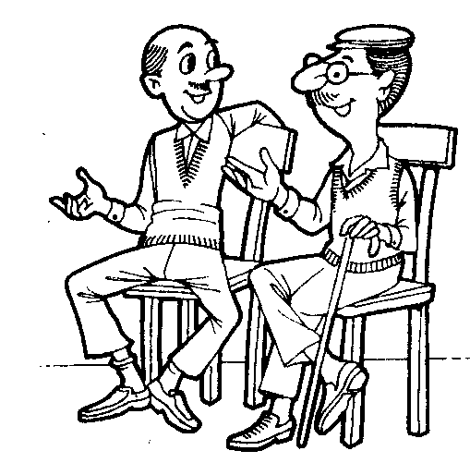

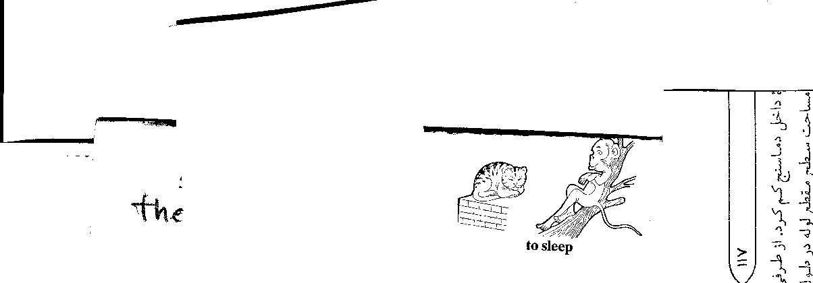 **1**. Which man is Mr. Alavi?

     The man…………………………….. .

**2**. Is there any water in the glass? (any/ no)

No, ………………………………………….

No, …………………………………………. (Wear hat)

**4- گزینه درست را انتخاب کنید. (3 نمره)**

**1.** There are ---------- forks on the table.

a)any b)no c)much d)little

**2.** My uncle has a car but this blue car isn׳t -------------.

a)yours b)his c)my d)mine

**3.** The bicycle ----------------he bought is new.

a)which b)that c)what d) a and b

**4.** The students --------------I teach are clever.

a)which b)whom c)what d)where

**5.** There --------- no bread on the table.

a)is b)are c)were d)be

**6.** I was happy because I -------------my friends.

a) see b)saw c)had seen d)have seen

مکا لمه

**پاسخ سئوالات قسمت A را از بين جوابهاي قسمت B انتخاب کنید. (یک پاسخ اضافی است.) (3 نمره)**

**A B**

**1.** Would you mind opening the door? ( ) a. I am a sailor.

**2.** How much does a kilo of rice cost? ( ) b. He is from Germany.

**3.** What do you do? ( ) c. You are welcome.

**4.** Where is your friend from? ( ) d .I am 16 years old.

**5.** How old are you? ( ) e .of course not.

**6.** What is your first name? ( ) f. About 40000 rials.

g. I am Muhammad.

تلفظ

**کلمات داده شده را با توجه به تلفظ آنها در ستون مربوطه بنویسید. 1 نمره**

**əu u: ju: au**

**(about / glow / new/ through)**

.......... .......... .......... ..........

درک مطلب

**1-با توجه به مفهوم جملات داده شده نزدیکترین گزینه را انتخاب کنید. (3 نمره)**

**1. « The other side of the moon is much like the side we see all the time. »**

This sentence says that ……………………

**a**. both sides of the moon are similar to each other

**b**. we can see both sides of the moon all the time

**c**. we like the other side of the moon more

**d.** we like the side of the moon we can see

**2. « The man had written a letter before he met his friend.»**

It means that----------------------.

**a.** He wrote the letter then he met his friend**.**

**b.** He met his friend then he wrote the letter

**c.** He wrote the letter when he was meeting his friend

**d.** He met his friend but he didn׳t write a letter

**3. « 1. I know the boy. Amir is looking at him. »** These sentences can be re – written as:

I know the boy……………

**a**. that he is looking at Amir

**b**. whom Amir is looking at him

**c**. who is looking at Amir

**d**. whom Amir is looking at

**2. متن زیر را به دقت بخوانید و به سئوالات آن پاسخ دهید.(4نمره)**

I have just received a letter from my brother, Tim. He is in Australia. He has been there for six months. He is an engineer. He is working for a big firm and he has already visited a great number of different places in Australia. He has just bought an Australian car and has gone to Alice Springs. My brother has never been abroad before, so he is finding this trip very exciting.

**1. What does the writer’s brother do?**

…………………………………………………………………………

**2. How long has he been in Australia?**

…………………………………………………………………………

**3. Where is Tim working?**

…………………………………………………………………………

**4. Is he enjoying his trip?**

…………………………………………………………………………

Oral work and class activity :(…… Out of 10)

Written Exam Score: (……. Out of 30)

Total Score: (…… Out of 40)

Teachers’ name & signature:

امام باقر (ع):

هر كس به ا... توکل كند، مغلوب نمی شود.

قطره ای از دریا: